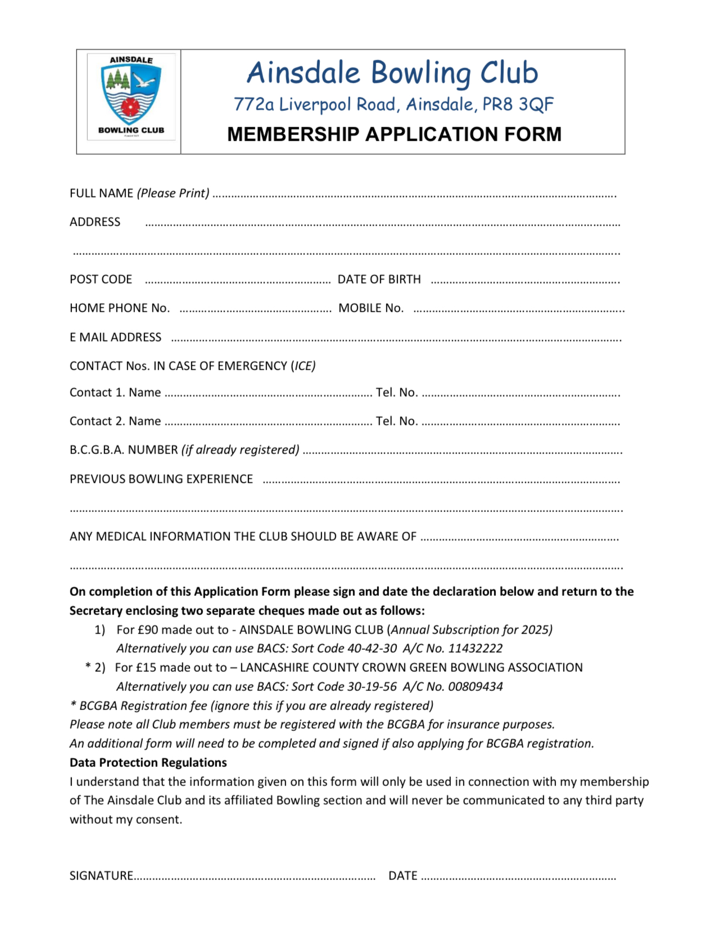
Hon. Sec. Simon Biddolph 16 Hatfield Rd. Ainsdale PR8 2PE Mobile 07753 854441

